June 7, 2018 Thursday Tours – 2 Choices

Registration is OPEN

All reservations must be made by Monday, 6/04 at NOON as facilities require a list of attendees prior to the event for security purposes. Please do not ask for an exception as we cannot honor one, per our commitment to the hosts. They must secure sufficient tour guides for the counts. Should the hosts require an earlier cut-off date, or the location specific maximum be reached, registration for that location will close.

Registration link is at the bottom of this message.

We have two tours lined up:
- KPS Global --- 4201 North Beach, Fort Worth, 76137
- Alcon ASPEX --- 270 E. Altamesa Blvd, Fort Worth, 76240

For more information or questions, contact John Breckline (817-401-0412)

SCROLL DOWN FOR FACILITY DETAILS (ONE TOUR PER PAGE)

1) KPS Global

Tour Scope: Manufacturing of coolers for retail outlets (i.e. gas self-service convenience stores).
Operations include wood & metal fabrication and final assembly.

Guidelines & Notable Restrictions:
- Minimum participant age: 10
- 70% walking/standing for 1 hour
- No citizenship restrictions
- Business casual dress preferred - no…shorts, open-toed shoes.
- Safety glasses required (supplied or bring your own)
- Steel-toe shoes required (wear yours if possible – toe covers provided otherwise)
- Camera use may be restricted

Max # of Participants: 35 members and guests

Tour Schedule: SEE BELOW

Location: KPS Global - Ft Worth
- On N. Beach St, just south of Meacham, on west side, across tracks
  - 4201 N. Beach St, Fort Worth TX 76137
MAPQUEST MAP

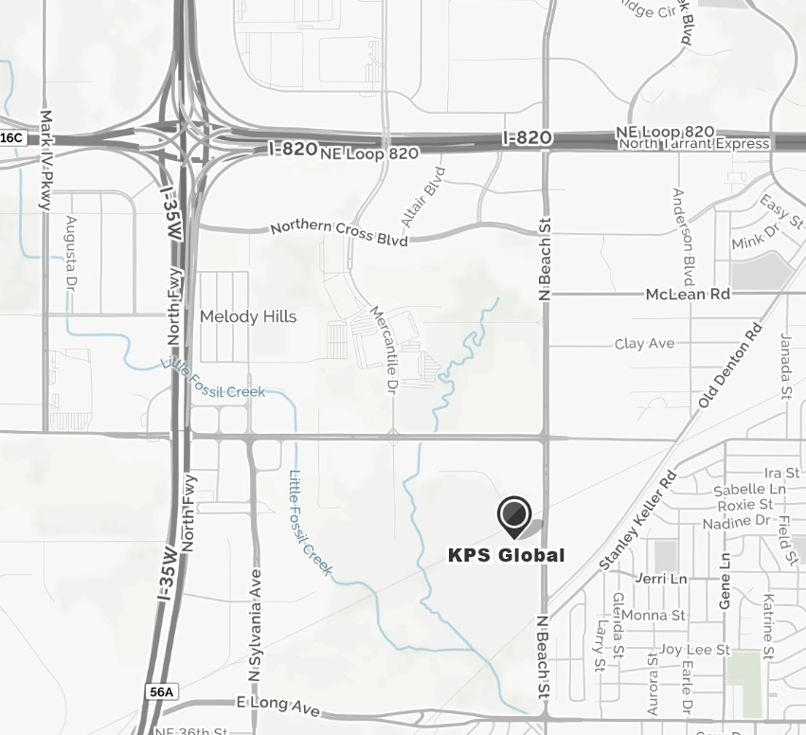

2) Alcon ASPEX

Tour Scope: Multiple Pharmaceutical production lines producing liquid aseptic (sterile) products.
Possible compounding, filling and packaging areas.

Guidelines & Notable Restrictions:
- Minimum participant age: 18
- No citizenship restrictions
- Clothing: may be asked to remove jewelry and watches. No food/gum during tour.
- Footwear: no open-toe shoes
- Competitors not permitted
- Photos: No cell phones, cameras or recording devices during tour.

Tour Schedule: SEE BELOW

Max # of Participants: 35 members and guests

- Location: Alcon Aspex
- 270 E. Altamesa Blvd, Fort Worth 76134
- Entry: DO NOT pull up to main security gate of the main campus (on left / FW Mfg)
  - Pull into smaller entry on South side of Altamesa (right turn into facility)
  - Guard will stop you, say ASQ tour.
  - Give host name: Tim Christian

GOOGLE MAP

- From I-35 coming from North to South, exit Altamesa at the I-35 / I-20 intersection.
- Coming East or West, may have to travel 1 exit south to Sycamore School Rd
  - THEN loop back north on service road to Altamesa east
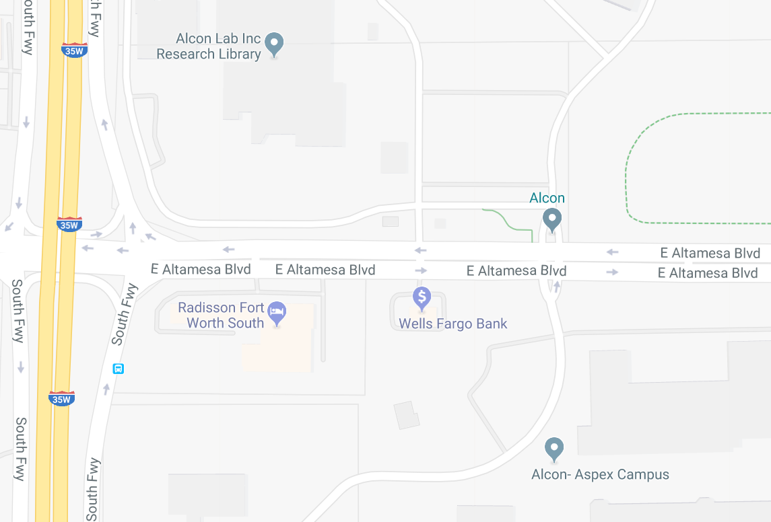

Click to register your choice: 2018 Tour Registration
https://asq.co1.qualtrics.com/jfe/form/SV_bpT5x006m7FV09f

REGISTRATION IS REQUIRED!

REGISTRATION CLOSES WHEN ALLOCATED SPOTS HAVE BEEN FILLED
OR ON JUN 04 at NOON … WHICHEVER IS SOONER

Register all participants individually – note criteria and restrictions

TOP
GENERAL FAQ:

What time do tours start?
Arrival Time: 5:30 pm-6:00 pm
Tour begins: 6:00 pm SHARP (late arrivals may be turned away)
Typical ending around 7:30-8:00
No meals are provided; plan on eating after the tour to assure you arrive on time.

How many people can sign up for a tour?
The tours are available on a first come/first served basis. Each facility has limited capacity noted above. When the limit is reached at any given site, the registration for that site will be closed.

How does each tour participant register?
Every tour participant must register individually.
No ‘group’ signups are permitted. If a member would like to register for a tour and would like to bring 2 family members, there must be 3 total registrations completed on the ASQ registration page.
Participant names must be provided to each organization’s Security Department for access 1 week prior to the tour.
Click to register: https://asq.co1.qualtrics.com/jfe/form/SV_bpT5x006m7FV09f Same as above link

Will I receive a confirmation and detailed directions to the tour site?
If you meet all of the requirements for the selected tour and complete an on-line registration, you are officially signed up for the tour.
Please assure a verified e-mail address when registering.
You will receive an additional e-mail confirmation prior to tour.

Who do I contact if I have questions?
For questions, contact John Breckline (817-401-0412)

