ASQ Greater Fort Worth - Section 1416 Meeting
Thursday, November 3, 2022
Live Meeting – Fall 2022 Location
-- Registration Required --

Registration at end of page
Posted 11/01/22

SPECIAL NOTICE: Food Drive – Collection Night

About Tarrant Area Food Bank
Tarrant Area Food Bank (TAFB) was founded in 1982 by a group of Fort Worth residents concerned about hunger in their community. It is now the primary source of donated food for hunger-relief charities and feeding programs in Tarrant and 12 surrounding counties, serving 1,000,000 meals each week.

TAFB serves people seeking food assistance in North Texas, to include unemployed and low-wage workers/families, senior citizens, chronically ill / disabled. More than 1/3 are children.

Please bring non-perishable packaged food (canned, dry goods, etc.) to the Nov 1 PDM.

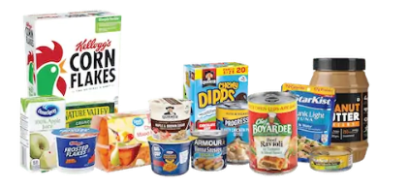

Program Topic: “Performance Levers:
How turnaround specialists rapidly improve company performance”

Not all processes have the same impact on company performance. Astute turnaround specialists employ many of the operations analysis tools and techniques used in the quality assurance profession to identify performance levers - those process that have a disproportionate effect on company financial or operating performance - improve those levers and maintain them in a state of control.

Our discussion will cover the identification and control of performance levers, including the use of practical examples, and how to maintain a state of control using emerging techniques such as predictive auditing

Speaker: Steve LeFavour, Managing Director, (investment bank in Dallas)

- Steve has a varied career in quality assurance
  - 35 year career in quality assurance and operational excellence
  - Tenures at US Navy submarine service, Caterpillar Mining and Peerless Manufacturing
  - Turnaround specialist for private equity firms. Has conducted 11 turnarounds in his career
  - PhD in metallurgy, MBA and Lean Six Sigma Master Black Belt

Tutorial 1: “TBD”

Tutorial 2: “First Article Inspection (FAI) – Right the First Time!”

The Term “First Article Inspection” means different things to different people. To some, it is a highly structured part qualification process imposed upon suppliers by customers at the beginning of a new business venture or with the introduction of new or changed parts.

To others, it is that process done at the beginning of a run or a shift or after a tooling change used to assure management that nothing has been forgotten overnight and that all the right setups are in place, the right material, labeling, components, processes, fixtures, jigs, and people have been brought to gather so that repeatable and acceptable parts can continue to be produced.

Because of these obvious differences in in the understanding of this term, we will touch on both during this presentation.

This is part 1 of a 2-part series... Dec topic is the PPAP Qualification Process

Speaker: Bob Mitchell, Retired (past Quality Manager)

- Bob Mitchell is a quality professional who for the past 30 years (following a 20 year military career) has worked in various quality roles including Quality Manager, Quality Engineer, Quality Supervisor, Quality Auditor and ISO 9001 Quality Systems Coordinator and Management Representative in industries such as Automotive, Telecom, Oil & Gas, Supply Distribution, and General Manufacturing.
- Bob has been a member of the Ft Worth Section Leadership Committee since 1997 serving in many positions of responsibility including 2 years as Section Chair. Bob holds ASQ Certifications: CQE, CQA, CSSGB and CQT. Bob also earned certification as Lead QMS Auditor through RABQSA (now known as Exemplar Global).
- Bob is a retired US Army Warrant Officer where he served as an Army Aviator (UH1H Pilot) and in Special Forces as an A-Team Executive Officer responsible for team Operations and Intelligence leadership. Bob maintains close ties with fellow military veterans serving as the Commander of the Wise County Veterans Group and as Vice President of the DFW Chapter of the Special Forces Association.
- Bob holds BS and MS in Engineering Technology from the University of North Texas.

Recognition: Senior Membership:
General recognition for Senior Members of the Section.

Prepaid Meal Purchase via Web:

For the new location, and to manage costs, we must have registrations for all attendees.
Reservations for meals must be completed by NOON on Wednesday to order meals from the caterer. Seat reservation will be available after that time, but no meal.

Until we return to the Diamond Oaks Country Club, we are renting rooms and must cover the cost of them by the attendees. With 50 attending, the distributed cost is about $6.00 per person.

We are using the new ASQ ePly system. Link: events.eply.com/PDMeetingRegistration

Choose: PD Meeting ASQ Dinner – to manage costs we are serving “box lunch subs”
- Meat / Italian (with cheese)
- Vegetarian / Vegan Option – a salad
- Gluten Free Option
- Just Program Access- room fee – No Meal ($6.00)
All meals options $25.00 include room fee

Sorry... system does not permit multiple meals in single transaction
All participants must register independently due to meal options

If problems, contact jbreckline@att.net

Typical Meeting Schedule:
5:30 – 6:00 Check-in – Networking
6:00 – Tutorial (30 min)
6:30 – Dinner – advance reservations required – no “meal” walk-in this meeting
Not required to have dinner to attend meeting but pay ‘seat fee’ (walk-in OK)
7:15 – Recognition and Short What’s Happening Meeting
7:30 – Program Speaker (45 min)
8:30 – Head on Home…

Location:
UNT Health Science Center –
3500 Camp Bowie Blvd
Carl E. Everett building
Fort Worth, TX 76107
MAP HOTLINK

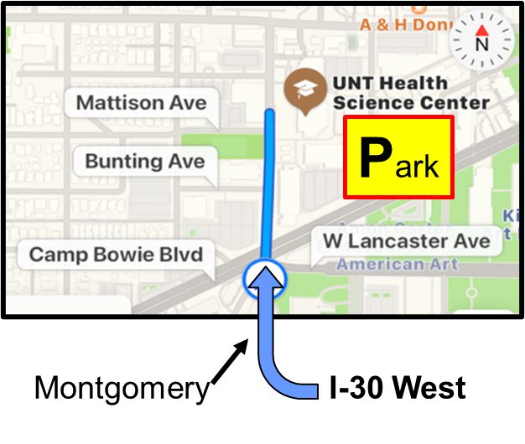  Enter Parking off Clifton Street  from Camp Bowie  says ADMIN – PARK HERE  Enter Carl E. Everett building  on SOUTH EAST corner  Elevator to 4th floor  Room EAD-406 | 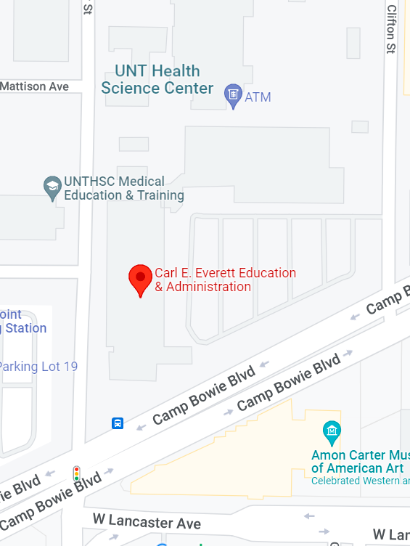  Park & enter

